Project Design Phase
Solution Architecture

Date | 04 October 2026
Team ID | Not provided
Project Name | Auto Ticket Classification using Flow Designer
Maximum Marks | 4 Marks

Solution Architecture:
Solution architecture is a complex process – with many sub-processes – that bridges the gap between business problems and technology solutions. Its goals are to:
- Find the best tech solution to solve existing business problems.
- Describe the structure, characteristics, behavior, and other aspects of the software to project stakeholders.
- Define features, development phases, and solution requirements.
- Provide specifications according to which the solution is defined, managed, and delivered.

Example - Solution Architecture Diagram:


Figure 1: Architecture and data flow of the voice patient diary sample application
Reference: https://aws.amazon.com/blogs/industries/voice-applications-in-clinical-research-powered-by-ai-on-aws-part-1-architecture-and-design-considerations/

Completed Solution Architecture
Auto Ticket Classification using Flow Designer
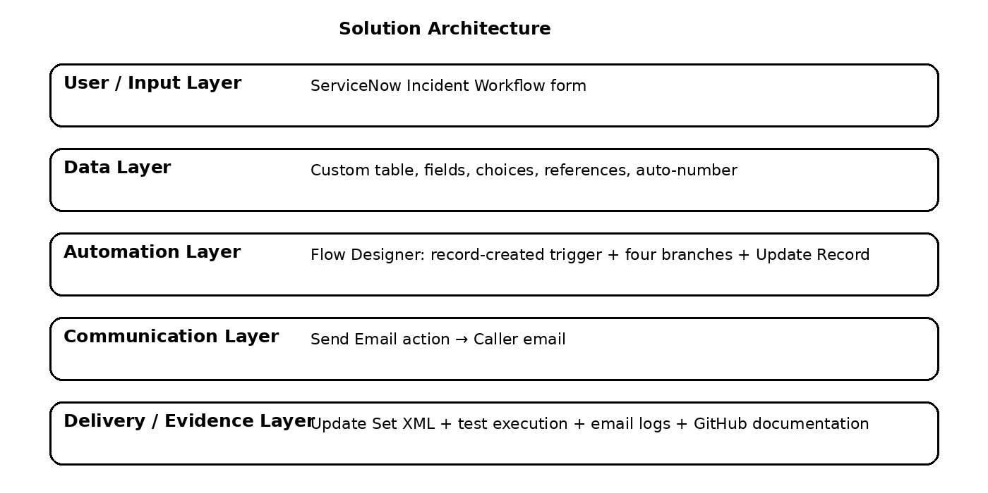
Figure: ServiceNow solution architecture for automated ticket classification.

Architecture Components
• Requester interacts with the ServiceNow Incident Workflow form.
• Record Created trigger starts the Auto Classify School IT Tickets flow when Category is empty.
• Flow Designer evaluates Short Description through Wi-Fi/Network, Project/Hardware, Access/ForgotPass and Performance/SlowComputer branches.
• Update Record writes the corresponding Category and Subcategory to the same Incident Workflow record.
• Send Email notifies the caller after the classification path completes.
• Project Update Set captures deployable configuration for transport.

